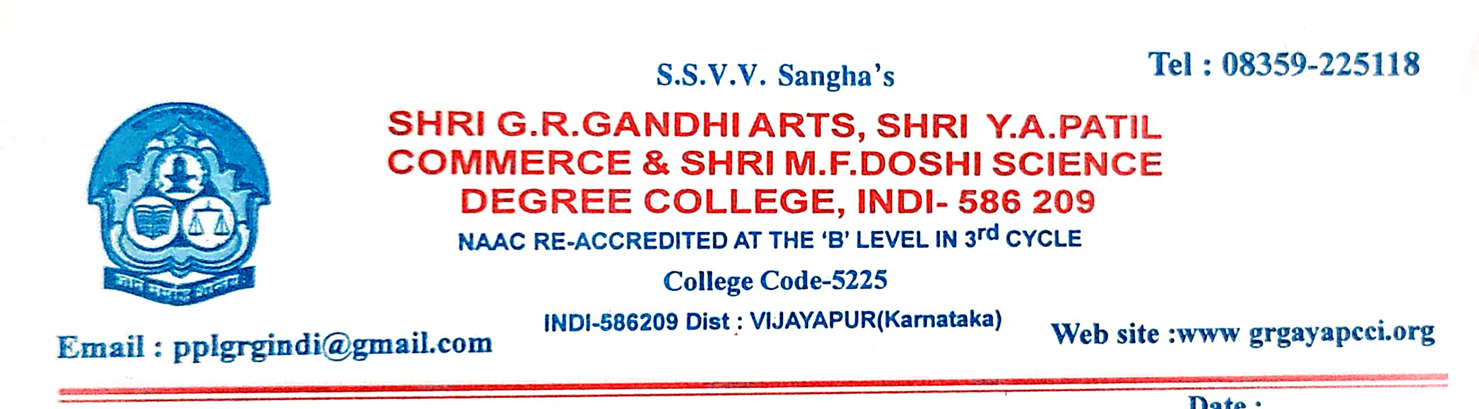
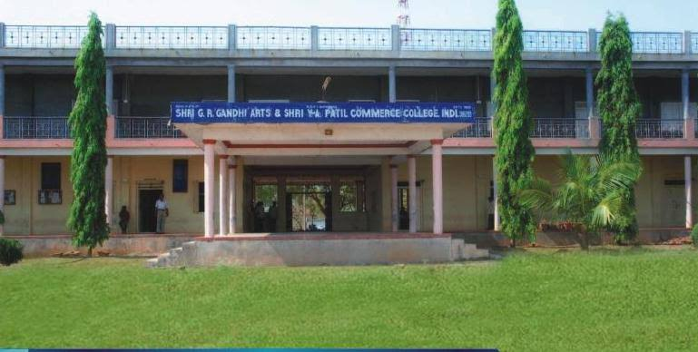
CRITERION VII – INSTITUTIONAL VALUES AND BEST PRACTICES Key Indicator - 7.1 Institutional Values and Social Responsibilities
7.1.3 - Describe the facilities in the Institution for the management of the following types of degradable and non-degradable waste (within 200 words)
1. Solid waste management
2. Liquid waste management
3. Biomedical waste management
4. E-waste management
5. Waste recycling system
6. Hazardous chemicals and radioactive waste management

7.1.3 - Describe the facilities in the Institution for the management of the following types of degradable and non-degradable waste (within 200 words)
1. Solid waste management
2. Liquid waste management
3. Biomedical waste management
4. E-waste management
5. Waste recycling system
6. Hazardous chemicals and radioactive waste management
The college facilitates several techniques for the management of degradable and nondegradable waste. The primary focus is to reduce, reuse and recycle the waste. The college management has also advised to refuse anything which is not needed. The college has different dustbins to segregate the different Solid waste management, Liquid waste management, Biomedical waste management, E-waste management AND Waste recycling system, etc. It is also advised that the college should use utensils made of glass and metal. For solid waste management different bins have been placed at different departments. It is also ensured that the recycling of all these components is done in minimum cost and labour. Suitable techniques are applied for disposing of solid waste. Moreover, wearing head gears, eye covers, apron, gloves and boots as they help in fighting the transmission of infection. The NSS volunteers have also demonstrated the proper procedure of disposing the waste in INDI. Waste recycling involves the collection of waste materials and segregation of the waste material. The university has set up a recycling programme to meet the need of recycling the waste. Hence, SSVV’s is determined to provide all possible facilities to deal with the degradable and non-degradable waste.

CLEANING THE CAMPUS
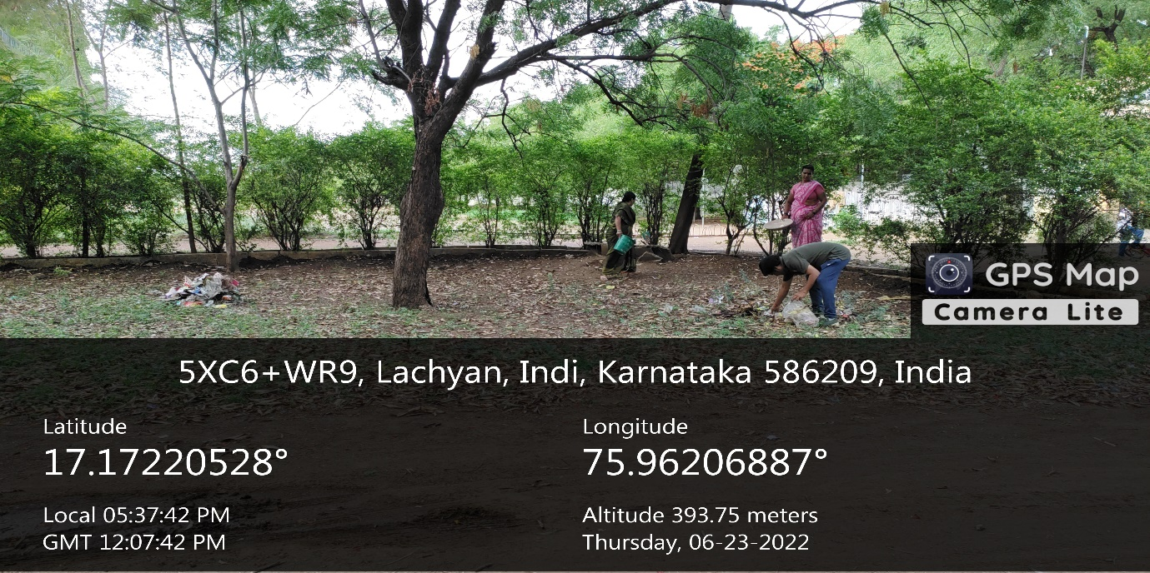

CLEANING THE CAMPUS

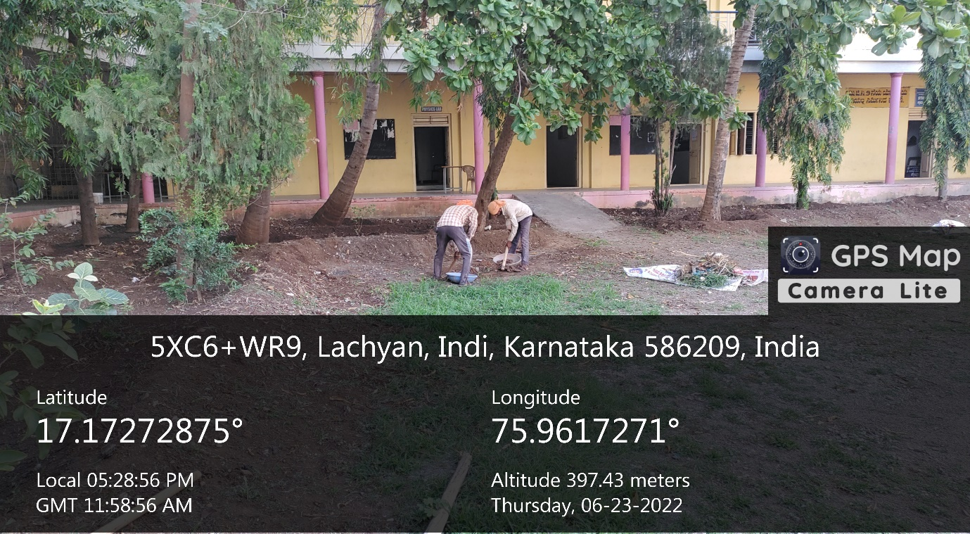

CLEANING THE CAMPUS

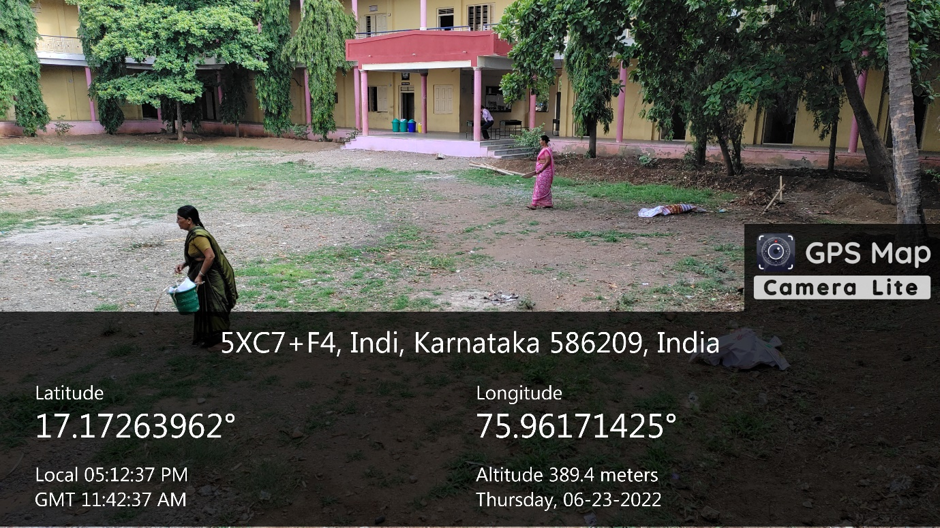

CLEANING THE CAMPUS

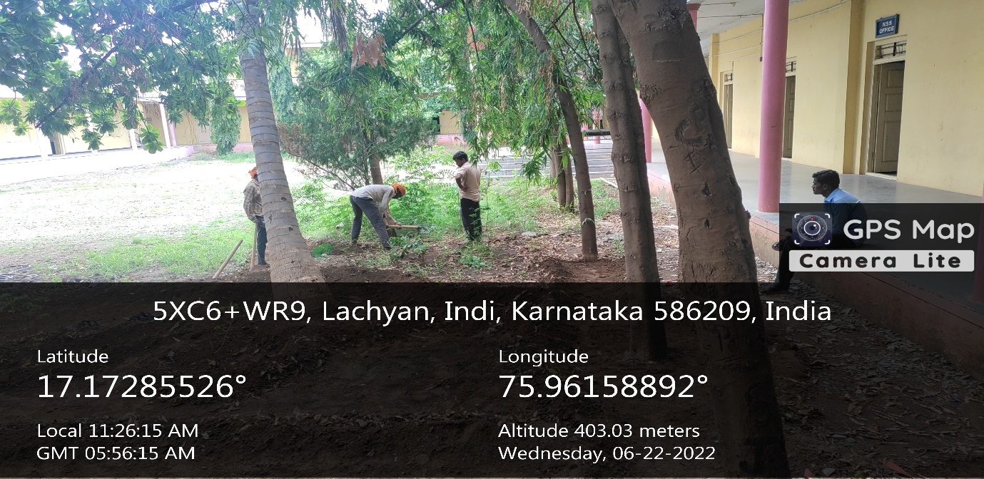
CLEANING THE CAMPUS

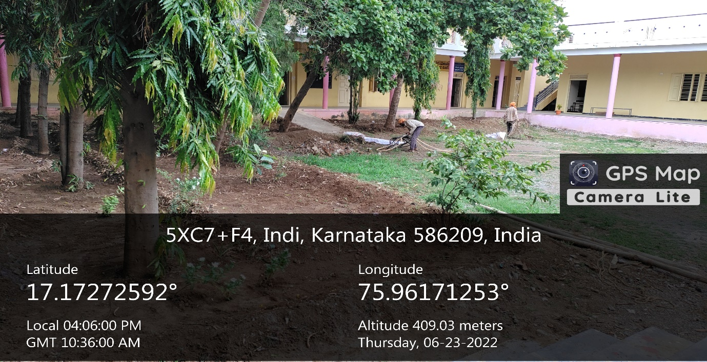

CLEANING THE CAMPUS

